



DECEMBER 2021



**Proposal for Establishment and**

**Upgrade of a Modern, Fully**

**Functional Emergency Operations Centre (EOC)**

TENDER NO: KSM/KCRH/EI/005/2021/2022

EXPRESSION OF INTEREST

**COUNTY GOVERNMENT OF KISUMU**

**KENLINKS SOLUTIONS LIMITED**

**YEAR: 2021**

KENLINKS SOLUTIONS LTD

**TABLE OF CONTENTS**

Preamble 2

Proposed Solution 3

Kisumu County Government Emergency Operations Centre – Project 10

Financial Implication 12

Reference of Similar Work Done 14

Some of Our Clients Around the World 16

Technical Team 16

Company Profile 20

Audited Accounts 23

Certificate of Partnership 24

Conclusion 25

Contact Details 26

# Preamble

The intended audience of this document is the Kisumu County Government Executive with the aim of engaging in a collaborative effort to ensure efficient and effective management of the Emergency Operations Centre in handling all emergency incidences / situations within the county. This proposal outlines the proposed project with a solution in mind domiciled at the County Government of Kisumu.

Kisumu County comprises seven (7) sub-counties with an approximate population of one million one hundred and sixty thousand people (1.16M) (source: KNBS 2019 census).

The County Government has established 21 hospitals and 149 primary health facilities that will grow to 34 hospitals (62% public) and 176 primary health care facilities (50% public) of levels II and III according to the financial year 2019-2020 Plan.

These facilities are supported by 20 ambulances, distributed across the Sub-Counties, health professionals and community health workers that must be managed and coordinated from the Emergency Operations Centre (EOC), to respond to all emergencies across the county.

Kenlinks Solutions Ltd in partnership with SayVU Technologies Ltd - Israel and Fika Systems have developed and integrated cutting-edge technologies to provide life-saving and personal safety solutions for people anytime & anywhere. Our mobile platform offers a comprehensive range of advanced, Innovative Home Land Security, Safe City and Internet of Things (IoT) solutions, allowing national and local authorities to ensure localities are well guarded with fixed and mobile locating capabilities as well as autonomous Emergency Notification Capabilities.

Our Digital Platform called SayVU is developed as a unique technology, supporting a modern digital communication system based on cellular and internet infrastructures. The system supports all the emergency solutions needed for lifesaving functions and the remote monitoring and control of individuals’ and groups’ safety needs at any time of any emergency event.

The SayVU platform enables the monitored users to notify and send alarm indications on any security breach and the emergency case(s) they pass through. SayVU can locate a user inside a building with the precision of a room and a floor (indoor positioning). It supports immediate notification of the event to the SayVU System Emergency Situations Monitoring Centre, that analyses associated risks and creates an effective reaction to quickly resolve the crisis through the assistance of First Responders’ forces – Ambulance Services, Fire Engines, Doctors, Nurses, Paramedics, First-Aid Workers etc. An important feature in our system is “mass notifications” that can be activated to all the application holders or to a specific area. For example, in the case of earth quack or in case of a dam collapse, or flush floods, we are able to notify everyone who has our application in this specific area to evacuate him/herself.

# Proposed Solution

There are many ways to describe emergency and public safety management and the importance of the task emergency managers perform. Indeed, in some respects, it hardly seems necessary to explain the need for a profession whose purpose is saving lives and property in disasters. Nobody expects an emergency or disaster – especially one that affects them, their employees, and their business personally. Yet the simple truth is that emergencies and disasters can strike anyone, anytime and anywhere. You and your employees could be forced to evacuate your business premises when you least expect it.

An emergency is an unforeseen situation that threatens your staff, customers or the general public; which disrupts or shuts down your operations; or cause physical or environmental damage. Some of our categorization of these emergencies include but not limited to the following:

*Floods * Fire * Toxic Gas Leaks * Chemical Spills * Explosions *Civil disturbance *Assault (Domestic Violence, Robbery, Mugging, Kidnapping, Rape) *Carjacking * Medical emergency – e.g. COVID -19, Cholera Outbreak, Malaria * Car accident * General Emergency

This brief is designed to help the County Government of Kisumu know how our digital platform comes in handy to help in the management of all types of emergencies in the shortest of times possible with minimal destruction of property and/or loss of lives.

Kisumu County being at the Centre of the Western and Nyanza region boasts of pilot projects in Healthcare, especially UHC (Marwa) and Agribusinesses. The healthcare system in the County is supported by various hospitals and also County’s First Response Ambulance Services. These are critical in Emergency response and with the collaborative effort with Kenlinks Solutions we shall make the County respond faster by ensuring that the general public use our SayVU Mobile App Platform – *Mobile 911inthe palm of your hands.*

SayVU is a cloud-based safety system that includes a web application and a smartphone application and provides real-time incident reporting and communication. The mobile app allows the user to autonomously report quickly and easily from any smartphone, even when the device is locked while collecting additional data and indications from the device’s sensors. The collected data, both subjective and objective, is sent immediately and autonomously to all emergency officials ("first responders") and Control Centers.

Additionally, SayVU shortens wait times and optimizes response time for emergency services by providing rich and relevant information about each incident directly to First Responders, according to their location and profession/training as well as to the Control Centre where the information is further analyzed. It, therefore, saves precious time that would otherwise be spent on phone calls and one-on-one communication.

## SayVU System Architecture

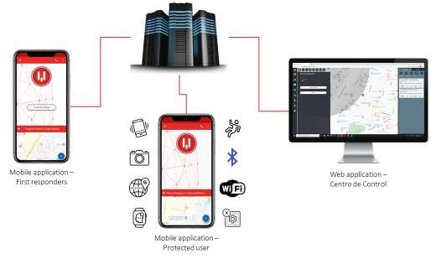

CGK-EOC



**Kenlinks–Cloud**

**Servers**



**Web**

**–**

**Application**

**CommandandControl**

**Centre**

## Emergencies and Personal Safety - Challenges

Many workplaces have determined to establish response mechanisms for the various emergencies as mentioned above. In all their efforts to establish best working approaches, there are a myriad of challenges which face these organizations as well as the general public:

1. Poor access to various emergency facilities because of roads infrastructure
2. Lack of ambulance services in all medical facilities however small
3. Lack of adequate fire engines in all sub-counties in Kenya
4. Lack of discipline in the public transport sector to ensure emergencies are handled based on certain prescribed policies and procedures
5. Lack of technology within the public safety spaces to intercept near accidents or report the same
6. Lack of public trust towards the police force in responding to emergencies efficiently

## What Emergency Action Plans Entail

At a minimum, emergency action plans should include the following:

1. A preferred method for reporting the said emergencies such as fire, assault etc
2. An evacuation policy and procedure
3. Emergency escape procedures and route assignments such as floor plans, workplace maps and safe or refuge areas
4. Names, titles, departments and telephone numbers of individuals both within and outside the company or organization to contact for additional information or explanation of duties and responsibilities under the emergency plan
5. Procedures for staff or employees who remain to perform or shut down critical plant operations, operate fire extinguishers or perform other essentials services that cannot be shut down for every emergency alarm before evacuating and
6. Rescue and medical duties for any workers designated to perform them

All the above plans must be put in place for any emergency to be handled with caution and ensure the public safety. In our engagement and survey in most counties, not all staff are prepared to handle emergencies and hence the need to establish an emergency unit.

This unit will be responsible for training, and ensuring the organization’s preparedness in handling any kind of alarm.

In our proposed solution we handle the various emergency categories and the general flow of how our solutions mitigates danger and adverse harm to any individual or even property. We start by reducing the many emergency telephone numbers to ONE button.

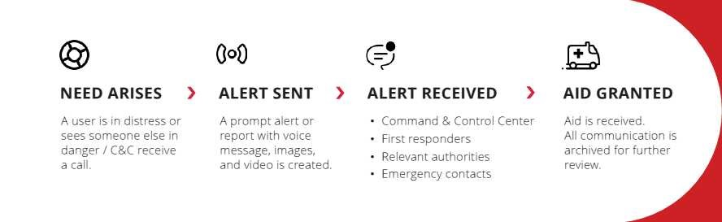

This image shows the start and continuum of process. By using an ICON on phone home screen all the necessary information goes directly to the hands of the EOC officers and these include:

Ambulance Drivers, Technicians (Nurses), Fire Department Operators as well Security Agencies.

## SayVU in Fire Response Services

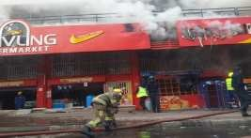Whenever a fire incident occurs in the any part of the county, most people panic before they can contain or even assess the situation. A local example very recently is the fire that burned down a Supermarket in Kisumu –Shivling Supermarket. This incident occurred during the day hence posing a number of threats and challenges in equal measure:

* People were at work
* They were not expecting the incident
* Maybe most of their fire extinguishers were not serviced or even functioning
* Due to the crowds in this area access by large fire engines could be a problem

Our digital platform, SayVU is completely versatile to handle the situation in the following manner.

* 1. 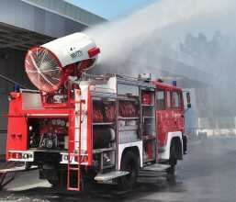The general public having the app on the phone taps the Fire Incident Icon or Emergency Icon.
  2. This causes an alert to be automatically generated and shared with the nearest fire Engine as well as the Command-and-Control Centre in less than two (2) seconds 3. The Command Centre and the Fire Department then get in touch with the person who tapped the button and can exchange more information. Part of the information

sharing could be the need for an Ambulance in case any person is trapped in a building or area and also the need to alert the Police force to be present in this rescue situation and also to handle further investigations.

4. The Command Centre monitors the autonomously dispatched Team of the Fire Department who are able to access the location and contain the fire in the shortest time possible, being ready to coordinate and assign more resources.

In the above example we see how efficient the SayVU digital platform comes in to rescue and save lives as well as property in a short response time.

## SayVU in Health Sector Response Covid-19: Case in Point

Emergency in the Health sector can be quite challenging especially when these occur in an unprecedented manner and densely populated areas in Kisumu County such as Nyalenda, Manyatta, Maseno or even the less densely populated areas. Healthcare in Kenya is experiencing some interesting times especially with the onset of Corona Virus and other communicable diseases.

For instance, using Covid-19 as the case in point, when reported for the first time in Kenya on 12th March 2020, the Ministry of Health had an Emergency Operations Centre comprising of four Rapid Response Teams. Each team had five trained medical staff as well as designated telephone numbers for the general public to report suspected cases, seek more information

on the infection and ask questions.

Some of the WHO recommended measures for preparedness to handle COVID-19 at country level included:

Surveillance focusing on rapid detection of imported cases

* Comprehensive and rapid case identification and contact tracing
* Monitoring the geographical spread and transmission intensity in areas where sustained community transmission has been detected
* Infection prevention and control measures at all levels of the healthcare system

The above approaches to handling a communicable disease such as COVID-19 are in all intent and purposes very impressive. Though a number of challenges are presented with the plan of response such as:

* Not sure if any member of the public remembers the telephone lines to be used to reach the healthcare teams
* No communication went out with reference to the geographical zones where the spreading and contact tracing was being done rapidly.
* The General public was supplied at most 3 or so SMS messages of the communication from the ministry and these were not sufficient

Our SayVU digital platform works as a panic button and has the Covid-19 push button. The subscribers of the app are able to use this button to send an alert to Ministry of Health (MoH) and in this scenario Kisumu County Health Department or other relevant healthcare providers within the County who can then respond to the incident. The general flow of the alert would be as follows:

## SEAMLESS FLOW OF PRECISE DATA FROM ANY SMARTPHONE

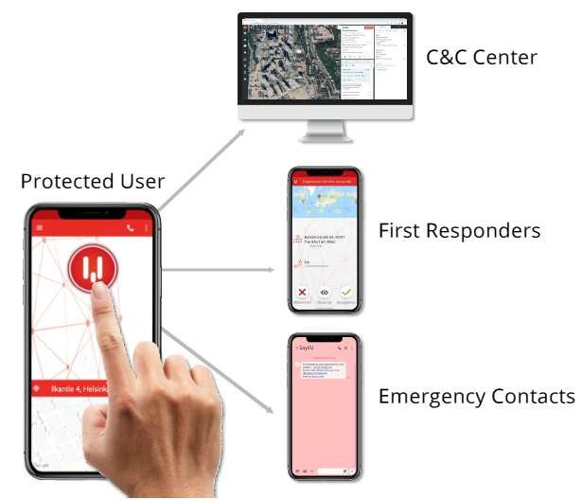

The above is an incident reporting process

1. User or member of the medical team taps the General Incident Reporting button on the App giving you a drop down menu
2. An Alert is immediately sent to the Command-and-Control Centre (C&C Centre), the field-based Staff/First Responders, and also the Department of Health in

Kisumu County in a matter of two seconds

1. 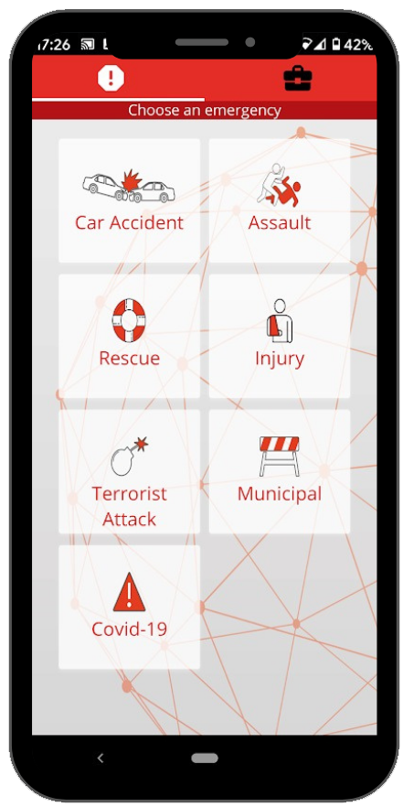The Command Centre (This will be domiciled in the Emergency Operations Centre) team and or Field-based Staff then can immediately get in touch with alert originator who could be a relative of a person infected or displaying symptoms of the infection or even neighbours or a good Samaritan.
2. Concurrently, the Command Centre Team scans through the Database of First Responders and loops them on the alert if they have not yet taken up the case. The team of first responders could be: Trained medical staff in the Rapid Response Team, Family Doctor of the user of the App or the infected person, nearest medical facility or ambulance service to the location of the incident.
3. Department of Health is also at the same time notified

of this alert and is therefore well informed. While all these developments are taking place, the App is generating maps, graphs and pie charts that can be used to zone the location of county therefore ensuring that proper informational material can be released to the general public with precision on infection transmission, areas of interest and contact tracing as well as medical evacuation plans.

1. Reporting is made available then to the relevant private and public agencies for effective and efficient containment of the situation.

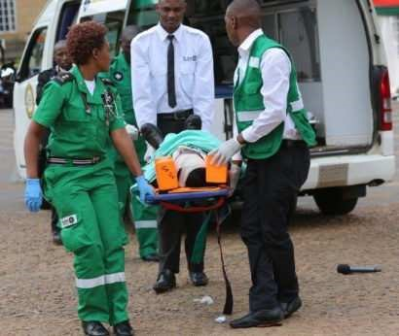

# Kisumu County Government Emergency Operations Centre – Project

The Recommended Deployment Approach

Given that the County Government of Kisumu has the below services:

* Universal Health Cover
* Ambulance Services
* Fire Engines
* Special Programmes Department
* Disaster Management Units

Kenlinks therefore recommends that we integrate the above services into the Emergency Operations Centre by using SayVU Digital Platform.

Kenlinks Solutions recommends the following approach to deploy the SayVU Digital Platform:

1. Establish a Command-and-Control Centre at the County Emergency Operations Centre
2. Train and Equip the County First Response Teams in the Use of the Application
3. Carryout campaigns to encourage the residents of the County to download and use the application
4. Monitor the use of the application and fine tune in-service use issues.

Based on the recommendation stated, the County Government of Kisumu will deploy the SayVU Digital Platform bringing in efficiency at their Emergency Operations Centre in the following way:

1. Approximately 200 plus critical healthcare staff for a start located in the over 210 healthcare facilities to be subscribed. The officers operating within the EOC shall have access to a Dashboard as below to access all alert related to the County Government of Kisumu to handle all traffic as they come.

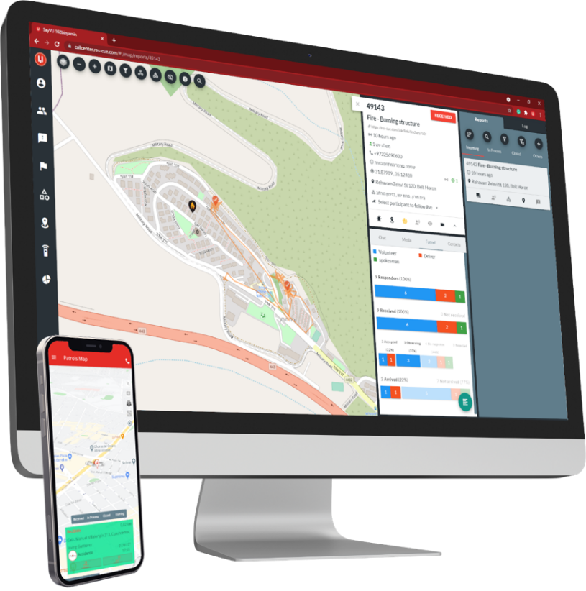

1. A Unique Command Centre Dashboard domiciled for the EOC and Kisumu County The above project will include the below budgetary implications:
2. Single User Subscription starts at only Kshs. 10
3. Dashboard Built for Kisumu County and hosted at Kshs. 50,000 per month
4. The Training and configurations included in the above cost.

# Financial Implication

There will be an initial cost to get the recommended solution deployed. Thereafter a user fee will be charged to sustain the operations

|  |  |  |  |  |  |
| --- | --- | --- | --- | --- | --- |
| **Item** | **Details** | **Qty** | **Unit Cost**  **(Kshs) Per Month** | **VAT on**  **Unit**  **(Kshs)** | **Total Cost (incl. VAT in Kshs)** |
| Backend  Software  Licenses1 | Must permit a minimum of 5  concurrent Users Cost of middleware, development tools and reporting tools must be included | LOT | 120 | 19.20 | 139.20 |
| Customization Deployment and Training | Customization of the Solution for Kisumu County | LOT | 50,000.00 | 8,000.00 | 58,000.00 |
|  |  |  |  |  |  |
| Equipment at the Emergency  Operations  Centre | Smart Monitor – 55’ (One-Off) | 2 | 60,000.00 | 9,600.00 | 139,200.00 |
| PC or Laptops for EOC | Core i5, 8GB RAM, 500 GB SSD (One-Off) | 2 | 80,000.00 | 12,800.00 | 185,600.00 |
|  | Training – User Training | 20 |  |  |  |
|  | Training – Senior Mgt | 10 |  |  |  |
| Maintenance  Agreement for 1st Year2 | Corrective, preventive, adaptive maintenance services | LOT |  |  |  |
| Maintenance  Agreement for 2nd Year2 | Corrective, preventive, adaptive maintenance services | LOT |  |  |  |
| Maintenance  Agreement for 3rd Year2 | Corrective, preventive, adaptive maintenance services | LOT |  |  |  |
|  |  |  |  |  |  |

1. Includes Hosting Users Data in A Secure Environment and allows for inclusion of applicable number of Users within the County Health Department
2. Includes all further Updates & Upgrades
3. Includes Web-Content-Management System (WCM) that allows build/updates Web-Sites

Financial Model explained for the County Government of Kisumu:

1. County Government of Kisumu Healthcare Department is proposing to pay the subscription fee indicated in the above financial section. This subscription of the application runs on the healthcare staff’s mobile phones or designate devices
2. The above subscription covering the enlisted healthcare staff will include the following category of staff:
   1. Facility Doctors
   2. Nurses
   3. Clinical Officers
   4. Ambulance Drivers
   5. Technicians in the Ambulance
   6. EOC staff – Administrators and Clerks
   7. Fire Engine Officers
3. County Government of Kisumu would dedicate to sponsor the UHC participants (Marwa Program) halfway and the UHC participants will pay half the cost. The cost is basically broken down as follows: Kes. 4 for each user. So, share the cost implies that 1:1 ratio.
4. One of the main advantages of deploying our solution amongst several benefits, is that the EOC will drastically reduce the cost implication on all the phone communications that must always take place. Currently, the general public dial the Toll Free line then the EOC staff respond by making a follow up call. These call take very long and hence the rapidly rising cost of making the calls. Based on the number of staff who must make the calls daily or even 24hrs a day, we can confidently propose that the substantial cost saving is going to happen for the EOC. The general public will utilize data to make calls through alerts and the EOC will be able to respond under 2 seconds hence saving lives and rescuing life threatening situation.

# Reference of Similar Work Done

|  |  |  |  |
| --- | --- | --- | --- |
| References of Similar Work | | | |
| **Name of**  **Reference** | **Challenges** | **Products**  **&**  **Services Main Features** | **Client Country of Region** |
| **Curico**  **Municipality**  **2018** | Challenges threatening  citizens safety and security. | Smart Incident  Management –  Flexible  System | Chile |
| **Weizmann**  **Institute of**  **Science –**  **2019**  **Sparta – 2021**  **Ministry of**  **Labour, Social**  **Affairs and**  **Social**  **Services**  **2021** | Safety of lone workers | SayVU  Solution –  Reports even from a Locked Phone  Smart Incident  Management  Real-time AI  Voice analysis  Scheduled  Alerts | Israel https://wis-wander.weizmann.ac.il |
| **Olympic**  **Games – Rio**  **2016** | Management of Events and participants.  When a sports man/woman is involved in an incident, then every second counts, quick  and efficient  first  responders’  dispatch can make the  difference  between life and death | SayVU  Solution – Handled the  Management of Incident Reporting,  Automated  Dispatch of  First  Responders Mobile Sensors monitoring | Brazil  https://www.timesofisrael.com/israeliemergency-tech-aims-to-make-rio-  attendees-safer/ |
| **Israel Fire and**  **Rescue**  **Services** | Fire destroys lives and  property. The need to know where a fire  incident and respond with | Using SayVU system as their automated dispatch  platform  enabled the  organization to enhance the | Israel  2019 |

|  |  |  |  |
| --- | --- | --- | --- |
|  | precision is  needed. | efficiency of its operation. |  |
| **Lavington**  **Security**  **-**  **2019** | A Test Pilot for Security Firms in Handling Security Alerts and Dispatch | SayVU  Solution – A Pilot Project run in House for the Security Firm in Testing their response to incident alerts and dispatch Platform | Kenya |

# Some of Our Clients Around the World



# Technical Team

### 1. Okotch Mondoh – Project Lead

* Okotch has the responsibility of actualizing business at Kenlinks Solutions Ltd. He identifies, plans for and executes opportunities that bring business. He helps recruit and put staff to work
* Okotch has nearly 30 years in Community Development work with direct impact for more than 5,000 families. He has a public record that includes Assistant Director of Education Quality Standards. For 10 years he has been a consultant in rural development focusing in rural development with an interest in technology and technology transfer for Agriculture, water and green energy in Africa-Israel axis

### 2. Benson Wasonga – Software Engineer & Technical Lead

#### Technical Director – Fika Systems

* Benson specializes in Security Solutions and having a background in Software Engineering, He has designed and developed, Data centric solutions and deployed the same for Central Depository and Settlement Corporation as well as UN agencies. Because of his expertise he consults widely for several organizations
* In-charge at Fika Systems for Enterprise Solutions and Technical Operations. Benson has initiated and successfully delivered a number of projects involving Enterprise Solutions with various organizations such as UNDP – Kenya, Somalia, Tanzania
* Successfully designed, implemented and Deployed an Enterprise Electronic Document Management Solution for Save the Children Somali, Kenya, Ethiopia and Uganda
* Successful implementation of Enterprise wide Digitization Security Solution for African Population and Health Research Centre
* Benson Holds a Master of Science Degree in ICT policy and Regulations and a certified Technology partner for various technology groups including Microsoft, HP, ELO Professional and the Institute of Science and Technology

### 3. Michael Osimbo – Systems Architect

* Michael has competencies in the Design, development and implementation of Mobile solutions for various needs and requirements such as Money Remittances.
* Technical consulting for Mara Properties and Intex Construction as a Systems Analyst as well as Software Development. He led the design and development team building the above entities solutions to manage and administer their operations
* Osimbo has proficiencies in various Technology platforms such as Oracle RDBMS and Microsoft technologies including .NET Frameworks and MS SQL. Which he has used in designing Data Mining and Data Managed Solutions.

### 4. Amotz Koskas – Technical Lead SayVU – Israel

* Amotz Koskas and team Amotz’s mission is to see that in a reality of growing and changing threats, SayVU is a solution that uses smartphone capabilities and remote server algorithm to smartly connect between users and emergency dispatches in case of emergency or distress.
* For over 5 years he has been Community Manager iCSI - Israel Crime Scene Innovation a Meetup, to collaborate around interests of lives saving, law enforcement and also cyber security. Before founding SayVU, Amotz had spent 6 years as the premier Bank Hapoalim as

Manager of Planning and Control Portfolio, Investments in Information Systems (IT), Infrastructures.

### 5. Shimi Yadan

* Shimi, Yadan has specialized in the development of a life-saving SOS button. His responsibilities involve writing REST API in Node.js which includes Express, Sequelize, and microservices as well as working with GCP, Kubernetes, Docker and AWS. Further competencies include Positive Apps specializing in the development of mobile applications, games, and web systems.
* His responsibilities involve writing an API in Angular (20%) and Node.js which includes Pug, Express, Koa, Sequelize (MySQL), gulp.js, Mongoose (MongoDB), pm2 and Nginx. We depend on Shimi to Program websites in Full-stack web development which requires the usage of JavaScript, PHP, HTML, Bootstrap, MVC in CodeIgniter framework and programming a game in C++ which required OOP and usage of design patterns, outside libraries like SFML, Boost and working in a team

### 6. Roman Rozenshtein – Software Developer

* Roman is Hands-On Mobile Solutions developer and has been responsible for mobile applications and SDKs development at SayVU for over 3 Years. He is a software architect and designs several modules of our solutions.
* Roman is a skilled and experienced Android developer, excellent team player and has been very reliable in several development task entrusted to him. He has been involved in the cutting-edge technology integration for SayVU that currently provides lifesaving and personal safety solutions into the Android application. He has designed and worked with the sensory awareness modules, GEO awareness, automatic events dispatch to call centres on emergencies and much more.



# Company Profile

Profile

About Kenlinks Solutions Ltd

Kenlinks Solutions Ltd is a technology products and services company. Our expertise is technological innovation in Information Management with offerings ranging from Software Solutions to Consulting and Outsourced Services. We believe the advance of technology is determined by the speed in which members of society exchange and process information. This belief has defined our development of technologies aimed at maximizing information access, processing, dissemination and storage.

Kenlinks Solutions Ltd was founded by passionate people, a common denominator among all who work here. The culture is casual, one that encourages staff to innovate, to excel and to get involved in all aspects of company operations.

Our Offering:

1. **Solutions**
   1. Personal and Public Safety Solutions
   2. Emergency Response Solutions
   3. Document management Systems
   4. Workflow Systems
   5. ERP Solutions Consultancy & Implementation
   6. CRM systems
   7. Security Surveillance
   8. Web Applications
   9. Solutions Integration
2. **Outsourcing**
   1. Imaging –Scanning and Indexing
   2. Back Office Operations
   3. Imaging and Printing Solutions
3. **Consulting**
   1. Document Management Policies
   2. Implementation and customization services
   3. Support
   4. Training

WHY KENLINKS?

Personnel / Right Skills:

We provide the right mix of skills for your project: At Kenlinks we have a team of highly qualified, hardworking and motivated people. We continually invest in research and training to ensure our people are on top of their game. We also adhere to international best practices in all fields in which we provide service.

We Are Adaptable:

Kenlinks does not sell a one-size-fits-all process. Rather, we pull from a wide range of techniques and scope, all projects present interesting design problems. The challenge is finding the best way to solve them. We work within available schedule and budgetary constraints. We can complete entire projects alone or work with extended client teams and other consultants. We can host projects, and also work on site or remotely.

We Are About Developing Great Solutions:

Kenlinks is focused on designing interface solutions that work for your staff, your goals and your business. We understand technologies as tools that are used to achieve a specific result.

We Produce Results:

Our work makes a difference. Our clients love us because we produce tangible results.

Best Practice:

We ensure adherence to world-wide information management best practice, to client best practices and to client industry standard practices.

Methodology:

**Kenlinks Solutions** recognizes that a clear understanding of a company’s existing business and documents is essential to the success of any imaging project. The analysis and design methodology set forth is devised to serve as a guideline to our process when devising a solution.

**Great Experience:**

Our experience in Solutions and imaging is vast having carried organizational projects for blue chip firms in Kenya.

Enterprise Wide:

What is unique about our experience is the fact that we handle all Departments in an organization rather than one. We can provide focused mono departmental solutions such as Accounts Payable & Receivable Shared Service Centres, or similarly enterprise-wide solutions, bringing out the best in each department. Therefore, be it HR, IT, Operations, Legal and so on, we have built great specialties.

Quality Control:

Quality is at the heart of what we do. Our products are 100% guaranteed.

Our Processes:

Our processes are well thought out, tried and tested. They ensure efficient, effective use of time and produce output high in quality and Quantity.

Confidentiality:

We put a great deal of emphasis on this. All our employees go through thorough vetting and have different clearance levels.

Security Of Documents and Data:

Paramount in all our projects is the Security of clients’ data and documents. We have elaborate systems in place using international best practice and our local experience.

# Audited Accounts

# Certificate of Partnership

# Conclusion

Kenlinks Solutions urges the County Government of Kisumu as well as the general public to embrace the use of our technology in the management of emergencies so as to help save lives, money and time.

We therefore present to all the counties and the entire region our most treasured digital Emergency response platform – SayVU for a better today and tomorrow.

Advantages of Implementing SayVU Emergency response Solution in the Emergency

Operations Centre in the County Government of Kisumu

|  |  |
| --- | --- |
|  | **CREATING SAFE COMMUNITIES WITH A RESPONSIVE & EFFICIENCT DISASTER** |
|  |
| **LIFE-SAVING DEVICE, INSIDE EACH POCKET**  **SayVU** converts each smartphone into a life-saving device. During an emergency, all smartphone’s sensors work together to tell the story of what’s going on-while its going on.  Automated and Manual alerts:   * Kisumu EOC Command and   Control Centre and staff with receive alerts and autonomous dispatch to the first responders activated in two (2) seconds   * Alerts from a locked phone * Shake to alert * Scheduled alerts * Fall detection * Hit Detection * Using an IoT devices or smartwatch | **MANAGEMENT COUNTY GOVERNMENT OPERATION** |

# Contact Details

KENLINKS SOLUTIONS LTD P.O BOX 102576 – 00101

736 A – TEBERE CRESCENT

KILELESHWA

PHONE: +254701922922

EMAIL: info@kenlinksolutions.com

solutions@kenlinksolutions.com

WEBSITE: www.kenlinksolutions.com

NAIROBI - KENYA